Lab: Batch Scoring in DSX

Mar 1st, 2018

Author: Elena Lowery elowery@us.ibm.com
Updated by: Sidney Phoon yfphoon@us.ibm.com
Table of contents
Contents
Overview 1
Required software, access, and files 1
Part 1: Load the sample project and create model 1
Part 2: Configure batch scoring of a model 2

Overview
In this lab you will learn how to configure batch scoring in DSX.

Required software, access, and files
- To complete this lab, you will need access to a DSX Local cluster.
- You will also need to download and unzip this GitHub repository: https://github.com/SidneyPhoon/DSX_Local_Workshop

Part 1: Load the sample project and create model

- If you haven’t already created a project from DSX_Local_Workshop.zip file, follow instructions for Use Case 1 in this repository https://github.com/SidneyPhoon/DSX_Local_Workshop

- If you haven’t run through the TelcoChurn notebook, run through it so that you generate a model. The easiest way to do this is to open the notebook, scroll down to Step 10, click on it, then in the menu select Cell -> Run all above.

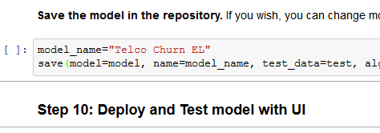

Navigate to the Assets view and make sure that the model has been created. Your model may have a different name and version.

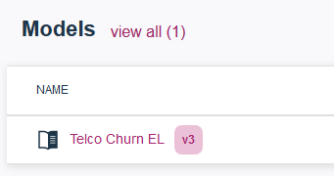

Part 2: Configure batch scoring of a model

- Click on the ellipses next to the model and select Batch Score.

- Fill out the required fields:

  - Input data set: new_customer_churn_data.csv (this data set contains data that should be scored)
  - Output data set: ScoringResults.csv. Make sure to provide .csv extension – otherwise you won’t be able to preview and download the output.

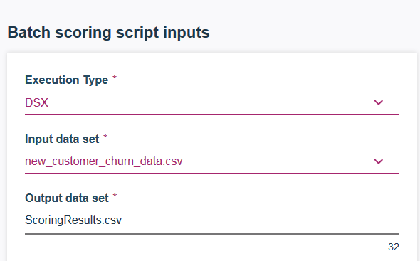

- Click on Advanced Settings and change the file name to ScoreTelcoCustomers. Click Save.



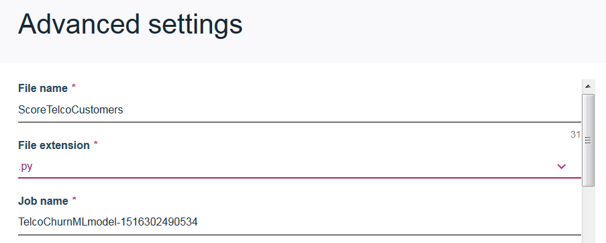

- Click Generate Batch Script. Then click Run now and wait till the status changes to Success.

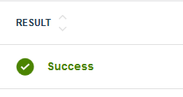

- Navigate to the Assets view of the project. Scroll down to Data Sets. You should see the generated ScoringResults.csv file.

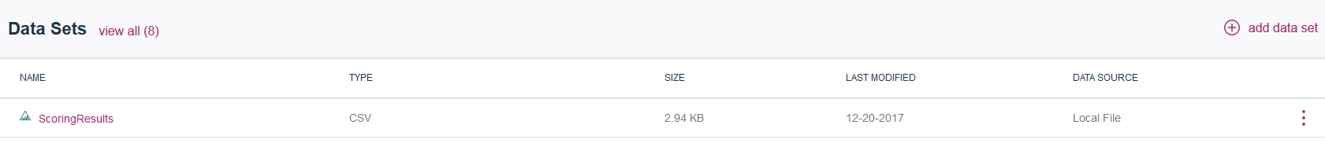

- You can choose to preview or download the file (click on the ellipses). The scoring results are the last few columns: rawPrediction, probability, prediction, predictedLabel.

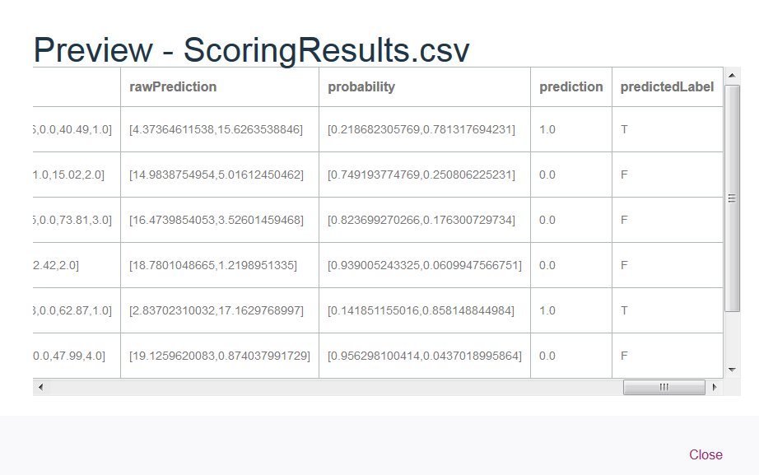

So far we have generated the batch job script and made sure that it works by running it interactively. Now we can schedule a batch job.

Schedule a Batch Job to Run Generated Script

- In the Project view scroll down to Scripts and click Create Job next to the script we created in previous steps.

- On the Create Job screen provide Job name and make sure to select the right Worker (Python 2.x or 3.x) environment (check comments in the notebook or check with the instructor). Scroll down and select either “on demand” or a specific time. Click Create.

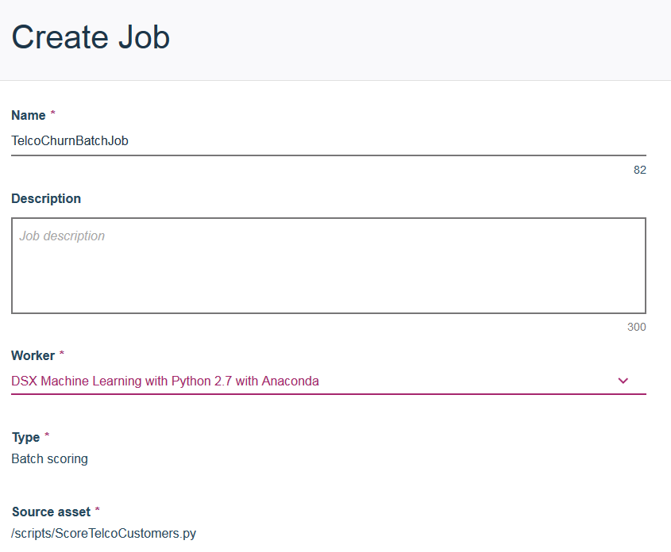

- In the Batch Job Details view scroll down and select Run Now.

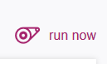

- Provide Run name and click Run.

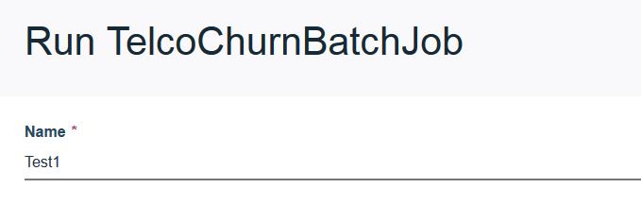

- Job status is displayed. Wait till status is “Success”.

- Navigate back to the Project view, and scroll down to data sets. Each batch job run overwrites the previous output file.

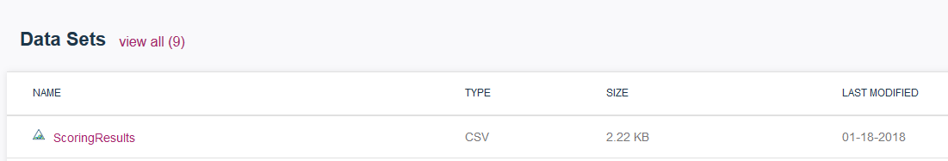

- If you want to make sure that the file was updated, open the RunSystemCommands notebook and run the commands (check the timestamp on ScoringResults.csv).

You have finished working on Batch Scoring in DSX lab.

